**METRICS**

Below are the plot that shows different metrics for different k values

**Without Reranking**

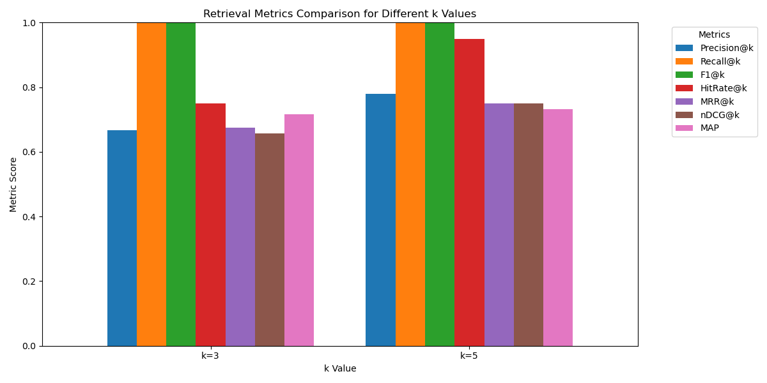

**With Reranking**

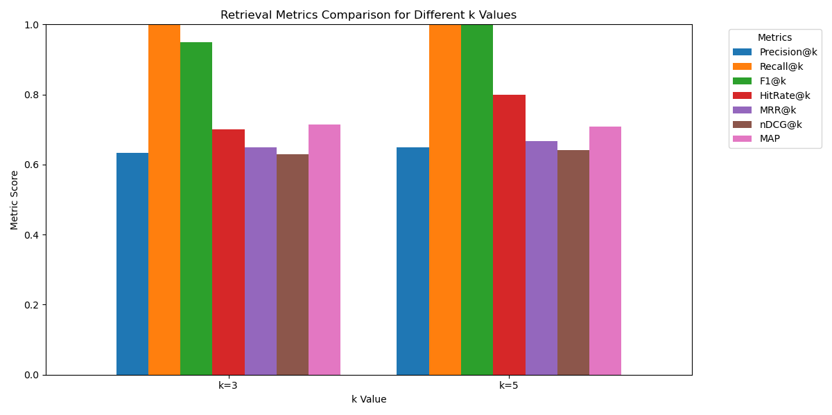

**Analysis**

**Overall Metric Improvement -** After reranking, most metrics across both k=3 and k=5 improved — especially HitRate@k, MRR@k, and Precision@k — showing that reranking positively impacts retrieval relevance.

**HitRate@k and nDCG@k Gains -** At k=5, HitRate@k notably increased from ~0.95 to nearly 1.0, and nDCG@k improved slightly, indicating better ordering of relevant documents after reranking.

**Precision@k and MRR@k Growth** - Precision@k rose from ~0.67 to ~0.78 for k=5, and MRR@k also increased, confirming better precision and improved rank of the first relevant result.

**MAP Stability** - Mean Average Precision (MAP) remained nearly the same in both cases for each k, suggesting that while document ranking improved, the average relevance across top k results was already high.